CPE301 – SPRING 2019

Design Assignment X

Student Name: Tian Chen

Student #: 2001086575

Student Email: chent5@unlv.nevada.edu

Primary Github address: https://github.com/Chentian12138/AAAABBBBB

Directory: DA_1

Submit the following for all Labs:

1. In the document, for each task submit the modified or included code (only) with highlights and justifications of the modifications. Also, include the comments.
2. Use the previously create a Github repository with a random name (no CPE/301, Lastname, Firstname). Place all labs under the root folder ESD301/DA, sub-folder named LABXX, with one document and one video link file for each lab, place modified asm/c files named as LabXX-TYY.asm/c.
3. If multiple asm/c files or other libraries are used, create a folder LabXX-TYY and place these files inside the folder.
4. The folder should have a) Word document (see template), b) source code file(s) and other include files, c) text file with youtube video links (see template).

1. **COMPONENTS LIST AND CONNECTION BLOCK DIAGRAM w/ PINS**

none

1. **INITIAL/MODIFIED/DEVELOPED CODE OF TASK 1/A**

;

; main.asm

;

; Created: 2/13/2019 1:33:19 PM

; Author : chent

;

.ORG 0

LDI r16, 0b00001000 ; Counter

LDI r24, 0b00001111 ; Mulitplicand low bit

LDI r25, 0b00001001 ; Mulitplicand High bit

CLR r18 ; LOW

CLR r19 ; MID

CLR r20 ; HIGH

LDI r21, 0b00000000 ; index counter

LDI r22, 0b00000101 ; Multiplier

LDI r23, 0b00000000 ; Temp variable

INDEX: ; Using bitmasking to find if it should go to shift or shift and add

MOV r17, r22 ; Bit masking index

ANDI r17, 0b00000001 ; Using bit masking to check the multlipier

BRNE SETUPVALUE ; If it is 1 than go to setup the value

BREQ SHIFT ; If it is 0 go to shift

SHIFT:

LSL r23 ; shift to the left of the temp variable

LSL r25 ; shift to the left of the high value

ADC r23, r21 ; add carry to the high value

LSL r24 ; shift the low bit

ADC r25, r21 ; add carry to the high value

LSR r22 ; shift right of the multipiler

DEC r16 ; counter --

BRNE INDEX ; if not 0 got back to bit masking

BREQ Done ; if it is 0 than done

SETUPVALUE:

ADD r18, r24 ; add the low value into final low

ADC r19, r21 ; add the low carry into mid

ADC r20, r21 ; add the low carry into high

ADD r19, r25 ; add the mid value into final mid

ADC r20, r21 ; add the mid carry into high

ADC r20, r23 ; add the temp variable into the high value

RJMP SHIFT

Done:

BREAK

1. **DEVELOPED MODIFIED CODE OF TASK 2/A from TASK 1/A**

none

1. **SCHEMATICS**

none

1. **SCREENSHOTS OF EACH TASK OUTPUT (ATMEL STUDIO OUTPUT)**

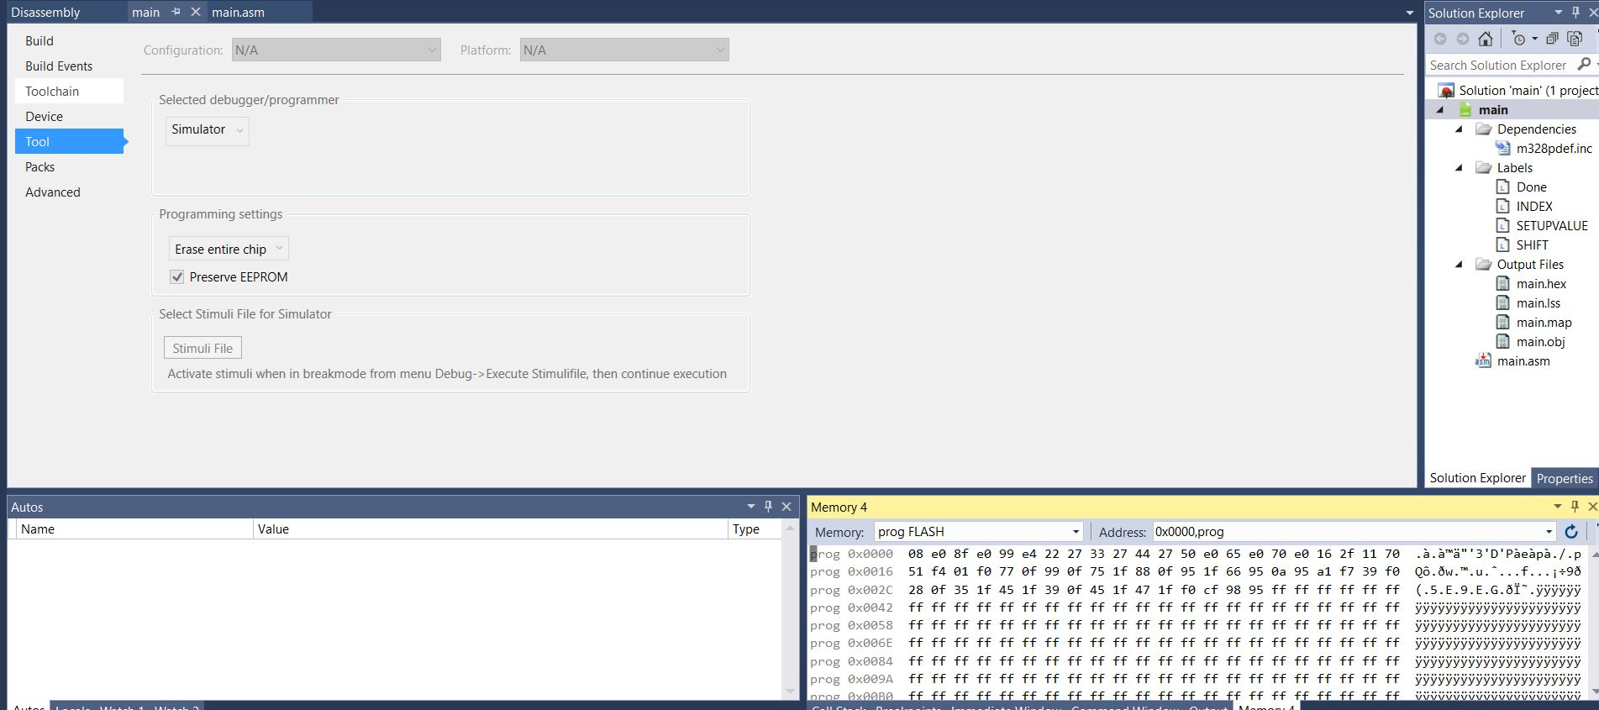

Matlab verify

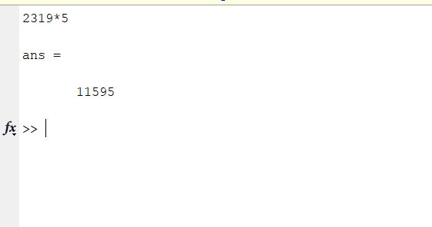

1. **SCREENSHOT OF EACH DEMO (BOARD SETUP)**
2. **VIDEO LINKS OF EACH DEMO**
3. **GITHUB LINK OF THIS DA**

**Student Academic Misconduct Policy**

<http://studentconduct.unlv.edu/misconduct/policy.html>

“This assignment submission is my own, original work”.

NAME OF THE STUDENT